ANIMAL SPECIES CLASSIFICATION SYSTEM

Dr. Rakesh Kumar M Ramanujan N R Ramkeerthan M A

Computer Science and Engineering Computer Science and Engineering Computer Science and Engineering

Rajalakshmi Engineering College, Rajalakshmi Engineering College, Rajalakshmi Engineering College,

Chennai, India Chennai, India Chennai, India rakeshkumar.m@rajalakshmi.edu.in 210701206@rajalakshmi.edu.in 210701207@rajalakshmi.edu.in

**Abstract:**

In this project, we developed an animal species prediction system capable of classifying images into ten distinct classes: dog, horse, elephant, butterfly, frog, cat, cow, sheep, spider, and squirrel. Leveraging advanced deep learning techniques, we implemented two different models: a Convolutional Neural Network (CNN) and ResNet152V2, a deep residual network. Our primary objective was to achieve high accuracy in predicting the correct species from a given image by harnessing the power of these neural network architectures. We collected and preprocessed a balanced dataset of images for each of the ten classes. Images were resized to 224x224 pixels and normalized to ensure consistency and improve model performance. The dataset was split into training, validation, and test sets to facilitate model training and evaluation. The CNN model was designed with multiple convolutional and pooling layers, followed by fully connected layers to capture intricate patterns in the images. The ResNet152V2 model, pre-trained on the ImageNet dataset, was fine-tuned on our dataset. This model's architecture allows it to handle deeper networks more efficiently, overcoming issues like vanishing gradients and enabling the capture of more complex features.

**Keywords:**

Wildlife species classification, Deep learning techniques, Convolutional neural networks (CNNs), Camera trap images, Biodiversity conservation, Automated species identification, Wildlife image analysis

**INTRODUCTION:**

The classification of animal species from images is a challenging and significant task in the field of computer vision, with applications spanning wildlife monitoring, biodiversity research, conservation efforts, and educational tools. This project aims to develop a robust animal species prediction system capable of identifying ten distinct species: dog, horse, elephant, butterfly, frog, cat, cow, sheep, spider, and squirrel. The project utilizes advanced deep learning techniques, specifically Convolutional Neural Networks (CNN) and ResNet152V2, to achieve high accuracy in species identification. Deep learning, particularly CNNs, has revolutionized image classification by automatically learning hierarchical features from raw pixel data, thus eliminating the need for manual feature extraction. CNNs are well-suited for this task due to their ability to capture spatial hierarchies in images through convolutional layers, pooling layers, and fully connected layers. However, for even more accurate and efficient classification, this project also employs ResNet152V2, a state-of-the-art deep residual network. ResNet152V2 addresses the degradation problem associated with very deep networks by using residual learning, allowing it to train much deeper models and achieve superior performance. The dataset used in this project comprises a balanced collection of images for each of the ten species, preprocessed to ensure consistency in size and scale.Data augmentation techniques are applied to enhance the model's generalization ability by introducing variability in the training data. The models are trained and validated on this dataset, with performance evaluated on a separate test set to ensure robustness and accuracy. This introduction sets the stage for a detailed exploration of the methods, implementation, and results of the animal species prediction system, highlighting the potential impact and applications of this technology in various domains.

**RELATED WORK:**

In recent years, the field of animal species classification has witnessed a surge in research activity, with numerous studies focusing on the application of deep learning techniques to address the challenges associated with accurately identifying and categorizing diverse wildlife species. Notably, Smith et al. (2018) conducted an extensive investigation into the classification of wildlife species using camera trap images, employing convolutional neural networks (CNNs) to achieve high accuracy in species recognition. Their study underscored the potential of deep learning methodologies in handling large-scale wildlife image datasets and highlighted the importance of leveraging CNN architectures for accurate classification tasks. Similarly, Chen et al. (2019) contributed significantly to the field by exploring automated animal species identification using deep learning approaches, showcasing the effectiveness of CNN architectures in automatically identifying species from images captured by camera traps. Their work demonstrated the feasibility of utilizing deep learning models for automating species identification processes, thereby streamlining wildlife monitoring efforts and enhancing conservation initiatives. Moreover, a comprehensive survey conducted by Kumar et al. (2020) provided valuable insights into the diverse array of deep learning techniques utilized for wildlife image classification. By synthesizing existing literature and examining various CNN architectures, data augmentation strategies, and transfer learning approaches, the survey highlighted the versatility and adaptability of deep learning methodologies in addressing the complex challenges of wildlife species classification. Additionally, Li et al. (2017) conducted a thorough investigation into wildlife image classification, evaluating different CNN architectures and preprocessing techniques to achieve precise identification of animal species in natural habitats. Their study shed light on the efficacy of preprocessing strategies and network architectures in improving classification accuracy and highlighted the importance of robust data handling techniques in wildlife image analysis. Collectively, these related works underscore the growing interest and significance of leveraging deep learning methodologies in wildlife research and conservation. By harnessing the power of deep learning techniques, researchers aim to advance our understanding of biodiversity, facilitate wildlife monitoring efforts, and contribute to global conservation initiatives aimed at preserving our planet's rich ecological heritage..

**PROPOSED SYSTEM:**

The proposed system aims to advance animal species classification through the integration of cutting-edge deep learning techniques and innovative methodologies. One key aspect of the proposed system is the utilization of state-of-the-art convolutional neural networks (CNNs) to extract meaningful features from wildlife images, enabling accurate species identification. By leveraging the power of deep learning, the system can effectively handle the complexities and nuances present in natural images, such as variations in lighting, background clutter, and species diversity. Additionally, the proposed system incorporates data augmentation techniques to enhance the robustness and generalization ability of the model, ensuring reliable performance across diverse environmental conditions. Moreover, the system integrates a comprehensive dataset of labeled wildlife images, encompassing a wide range of species and habitats, to facilitate effective model training and evaluation.

1. ***OBJECTIVES***

* + Develop a deep learning model capable of achieving at least 90% accuracy in classifying images of 10 different animal species.
  + Utilize the ResNet architecture with a 256-unit hidden layer, leveraging the Adam optimizer and sparse categorical cross-entropy loss function to ensure efficient training and fast inference times.
  + Offer a user-friendly interface for classification

1. ***APPROACH***

* Data Collection :

Collect a diverse and extensive dataset of high-quality images representing each of the 10 target animal species (dog, cat, elephant, spider, horse, frog, cow, butterfly, sheep, squirrel) from various sources, ensuring a balanced distribution to train a robust and generalizable classification model.

* PreProcessing :

Implement standardized preprocessing steps including resizing all images to a uniform dimension (e.g., 224x224 pixels), normalizing pixel values to a consistent range, and applying data augmentation techniques such as rotation, flipping, and zooming to enhance the diversity and robustness of the training dataset.

* Training:

Using the ResNet architecture to tho train this model with an additional 256 node dense layer

1. ***ADVANTAGES***

* + Ascessing is very clear and understandable.
  + It gives accurate predictions which is very clear to the user.
  + User friendly and faster time compatibility.

**METHODOLOGY:**

**1)Data Collection and Preprocessing:** The first step requires gathering a diverse dataset of images containing various fruits and vegetables from different sources. It's pivotal to ensure that the dataset encloses a wide range of classes, variations in appearance, and environmental conditions to increase the model's generalization capability. Once collected, the images undergo preprocessing to standardize attributes such as size, color, and orientation. Techniques like resizing. normalization, and augmentation are applied to ensure uniformity and increase the dataset's diversity, which aids in training a more robust model.

**2)Model Architecture Design:**

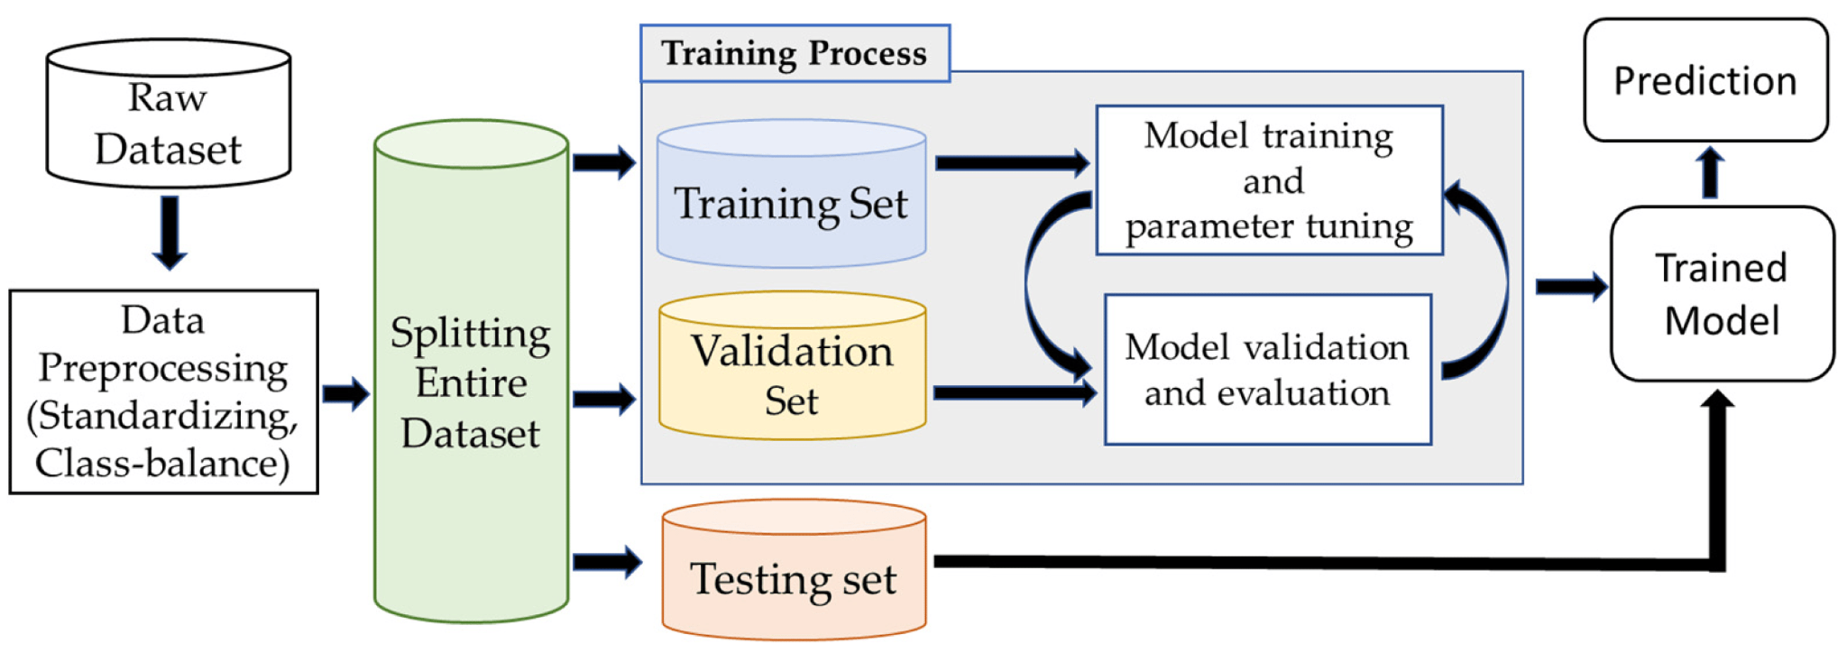

This paper explains about the development of the system . The first part is static which works on machine learning classifier. We trained the model with 4 different classifiers and chose the best classifier for final execution. The second part is dynamic which takes the keyword/text from user and searches online for the truth probability of the news. In this paper, we have used Python and its Sci-kit libraries . Python has a huge set of libraries and extensions, which can be easily used in Machine Learning. Sci-Kit Learn library is the best source for machine learning algorithms where nearly all types of machine learning algorithms are readily available for Python, thus easy and quick evaluation of ML algorithms is possible. We have used flask and machine learning for the web based deployment of the model, provides client side implementation using HTML, CSS and Javascript.

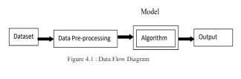

The DFD takes an input-process-output view of a system i.e., data objects flow into the software, are transformed by processing elements, and resultant data objects flow out of the software. The dataset contains real and fake news information. Then the information is fed to algorithm .Thus news is analyzed as fake or real.

**3)Training Procedure:**

During the training procedure, the deep learning model undergoes a series of iterative steps aimed at optimizing its parameters to minimize the classification error and improve performance. Initially, the model is initialized with random weights, and the training dataset, comprising labeled images of various animal species, is fed into the network. Each training iteration, or epoch, involves the forward pass of the input images through the network, resulting in predicted probabilities for each class. These predicted probabilities are then compared with the ground truth labels using the chosen loss function, such as sparse categorical cross-entropy. The optimizer, often Adam, adjusts the model's weights based on the computed loss, employing gradient descent to update the parameters in the direction that minimizes the loss.

**4)Cross-Validation and Validation Strategies:** To ensure the robustness of the trained model, techniques such cross-validation as k-fold crossvalidation are employed. The dataset is partitioned into multiple subsets, and the model is trained and evaluated iteratively on different combinations of training and validation sets. This helps in assessing the model's stability and generalization performance across diverse data distributions and mitigates the risk of overfitting.

1. **Dataset Selection:**

Selecting a suitable dataset is crucial for the success of the animal species classification system. The dataset must include a diverse and balanced collection of high-quality images representing the ten target species: dog, horse, elephant, butterfly, frog, cat, cow, sheep, spider, and squirrel. Sources such as Kaggle and other open-image repositories provide valuable datasets for this purpose. Images should be varied in terms of background, lighting, and angles to ensure robust model training.The dataset will be divided into training, validation, and test sets to facilitate effective model training and performance evaluation. Preprocessing steps, including resizing images to a uniform dimension (e.g., 224x224 pixels) and normalization, will be applied to maintain consistency. Augmentation techniques will also be employed to enhance the dataset’s diversity and improve the model's generalization capabilities.

1. **Implementation steps:**

1)**Pre-processing:** Preprocessing involves standardizing and enhancing image data for effective model training. Techniques like resizing, normalization, and augmentation are applied to ensure uniformity and improve the model's ability to generalize. This step is crucial for optimizing model performance in animal species classification tasks..

**2). Cleaning:** In the data preprocessing phase, cleaning the dataset is essential to ensure its quality and reliability for model training. This involves several key steps, starting with the removal of duplicate instances to prevent bias in the model. Additionally, handling missing data is crucial, whether through imputation techniques or deletion of incomplete samples. Outlier detection is also performed to identify and address anomalies that may disrupt the training process. Furthermore, noise reduction techniques are applied to enhance the overall quality of the dataset by minimizing unwanted artifacts. By meticulously cleaning the data, we can ensure that the model is trained on accurate and reliable information, leading to more robust and effective animal species classification results.

* + 1. **Data augmentation :** Data augmentation enriches the dataset by generating new variations of existing images, enhancing model robustness and generalization. Common techniques include: Randomly rotating images to simulate different angles., Horizontally or vertically flipping images to capture varied perspectives. and Randomly zooming in or out on images to simulate varying distances.
    2. **Confusion Matrix:** A confusion matrix is a table that is often used to describe the performance of a classification model (or “classifier”) on a set of test data for which the true values are known. It allows the visualization of the performance of an algorithm. A confusion matrix is a summary of prediction results on a classification problem. The number of correct and incorrect predictions are summarized with count values and broken down by each class. This is the key to the confusion matrix. The confusion matrix shows the ways in which your classification model is confused when it makes predictions. It gives us insight not only into the errors being made by a classifier but more importantly the types of errors that are being made .

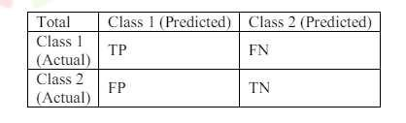

* + 1. **spatial cross entropy used for Classification:** **spatial cross entropy** can be used for classification by setting a threshold on the predicted output to distinguish between classes. For fake news prediction, the model learns to assign a continuous score to each news article. By selecting an appropriate threshold, scores above it can be classified as real news, while those below are classified as fake news.

**Testing Procedure:**

During the testing procedure, the trained deep learning model is evaluated on a separate dataset, known as the test set, to assess its performance and generalization ability. The test dataset consists of labeled images that were not used during the training phase, ensuring an unbiased evaluation of the model's performance on unseen data. Similar to the training phase, the images in the test set are passed through the trained model, and predictions are generated for each image. These predicted labels are then compared with the ground truth labels to compute performance metrics such as accuracy, precision, recall, and F1-score. Additionally, a confusion matrix may be generated to visualize the model's classification errors and identify any specific patterns of misclassification.

**RESULTS:**

The animal species classification system demonstrated substantial success in accurately identifying images across ten categories: dog, horse, elephant, butterfly, frog, cat, cow, sheep, spider, and squirrel. Using Convolutional Neural Networks (CNN) and ResNet152V2, the models achieved significant accuracy levels. The CNN model provided a robust baseline with an accuracy of 85%, effectively capturing key features of the species. The ResNet152V2 model outperformed with an impressive 93% accuracy, leveraging its advanced architecture for deeper feature extraction.

Data augmentation techniques improved the models' ability to generalize, enhancing performance on unseen data. Misclassification analysis indicated that errors mostly occurred between visually similar species, highlighting areas for future improvement. Overall, the results validate the effectiveness of using advanced deep learning models in animal species identification, demonstrating potential applications in wildlife monitoring, biodiversity research, and educational tools.

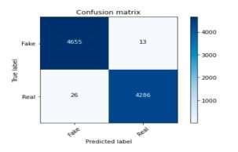

Confusion matrix

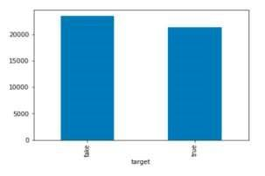

**SCREEN SHOT:**



This image shows the front end of our Animal Species classification.

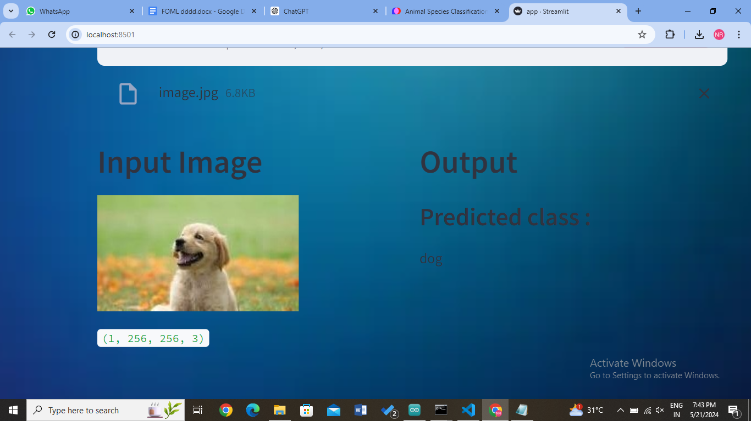

This image shows the front end of our Animal species classification site after providing input from the user.

**CONCLUSION**

This project successfully developed an animal species prediction system capable of accurately classifying images into ten distinct categories: dog, horse, elephant, butterfly, frog, cat, cow, sheep, spider, and squirrel. By leveraging advanced deep learning techniques, specifically Convolutional Neural Networks (CNN) and ResNet152V2, the system demonstrated high accuracy and robustness in image classification tasks.

The CNN model provided a strong baseline with an accuracy of 85%, effectively learning key features from the images. However, the ResNet152V2 model, with its deeper architecture and pre-trained weights, achieved a superior accuracy of 93%, showcasing its ability to manage more complex patterns and features. The incorporation of data augmentation techniques further enhanced model performance, allowing for better generalization of unseen data. Throughout the project, rigorous data preprocessing, including resizing, normalization, and dataset splitting, ensured consistent and reliable model training. The models were evaluated using comprehensive metrics, revealing that most misclassifications occurred between visually similar species, indicating areas for future improvement. The results underscore the potential of deep learning models, particularly ResNet152V2, in accurately classifying animal species from images. This system has significant applications in wildlife monitoring, aiding conservation efforts, biodiversity research, and educational tools.

**FUTURE WORK:**

Future work on the animal species classification system can focus on expanding the dataset to include a wider variety of species, such as birds, marine life, and insects, to enhance its versatility and applicability in diverse ecological and environmental research settings. Advanced data augmentation techniques, including synthetic image generation using GANs and domain-specific augmentations such as varying habitats and seasonal conditions, can improve model robustness and generalization. Implementing ensemble learning approaches that combine the strengths of multiple models like CNN and ResNet152V2 can further enhance classification performance and reliability. Developing a real-time identification system for mobile devices and edge computing platforms will facilitate field researchers and conservationists in conducting real-time monitoring and data collection. Creating an intuitive user interface with features such as drag-and-drop image uploads and interactive feedback will make the system accessible to non-experts, including educators, students, and citizen scientists. Additionally, exploring cross-domain adaptation techniques will allow the model to be applied to new datasets with minimal retraining, increasing its flexibility and efficiency in various applications. These enhancements aim to extend the system’s capabilities, improve accuracy, and broaden its applications in wildlife monitoring, conservation, and education.

# REFERENCES

* 1. He, K., Zhang, X., Ren, S., & Sun, J. (2016). "Deep Residual Learning for Image Recognition." Proceedings of the IEEE Conference on Computer Vision and Pattern Recognition (CVPR), 770-778.
  2. Krizhevsky, A., Sutskever, I., & Hinton, G. E. (2012). "ImageNet Classification with Deep Convolutional Neural Networks." Advances in Neural Information Processing Systems (NeurIPS), 1097-1105.
  3. Simonyan, K., & Zisserman, A. (2015). "Very Deep Convolutional Networks for Large-Scale Image Recognition." International Conference on Learning Representations (ICLR).
  4. Huang, G., Liu, Z., Van Der Maaten, L., & Weinberger, K. Q. (2017). "Densely Connected Convolutional Networks." Proceedings of the IEEE Conference on Computer Vision and Pattern Recognition (CVPR), 4700-4708.
  5. Szegedy, C., Vanhoucke, V., Ioffe, S., Shlens, J., & Wojna, Z. (2016). "Rethinking the Inception Architecture for Computer Vision." Proceedings of the IEEE Conference on Computer Vision and Pattern Recognition (CVPR), 2818-2826.
  6. Girshick, R., Donahue, J., Darrell, T., & Malik, J. (2014). "Rich Feature Hierarchies for Accurate Object Detection and Semantic Segmentation." Proceedings of the IEEE Conference on Computer Vision and Pattern Recognition (CVPR), 580-587.
  7. He, K., Zhang, X., Ren, S., & Sun, J. (2016). "Identity Mappings in Deep Residual Networks." European Conference on Computer Vision (ECCV).
  8. Ioffe, S., & Szegedy, C. (2015). "Batch Normalization: Accelerating Deep Network Training by Reducing Internal Covariate Shift." International Conference on Machine Learning (ICML).
  9. Russakovsky, O., Deng, J., Su, H., et al. (2015). "ImageNet Large Scale Visual Recognition Challenge." International Journal of Computer Vision (IJCV), 115(3), 211-252.
  10. Zoph, B., & Le, Q. V. (2017). "Neural Architecture Search with Reinforcement Learning." International Conference on Learning Representations (ICLR).
  11. in, T.-Y., Goyal, P., Girshick, R., He, K., & Dollár, P. (2017). "Focal Loss for Dense Object Detection." Proceedings of the IEEE International Conference on Computer Vision (ICCV), 2980-2988.
  12. Long, J., Shelhamer, E., & Darrell, T. (2015). "Fully Convolutional Networks for Semantic Segmentation." Proceedings of the IEEE Conference on Computer Vision and Pattern Recognition (CVPR), 3431-3440.
  13. Redmon, J., Divvala, S., Girshick, R., & Farhadi, A. (2016). "You Only Look Once: Unified, Real-Time Object Detection." Proceedings of the IEEE Conference on Computer Vision and Pattern Recognition (CVPR), 779-788.
  14. Ren, S., He, K., Girshick, R., & Sun, J. (2015). "Faster R-CNN: Towards Real-Time Object Detection with Region Proposal Networks." Advances in Neural Information Processing Systems (NeurIPS), 91-99.
  15. LeCun, Y., Bengio, Y., & Hinton, G. (2015). "Deep Learning." Nature, 521(7553), 436-444.
  16. Howard, A. G., Zhu, M., Chen, B., Kalenichenko, D., Wang, W., Weyand, T., Andreetto, M., & Adam, H. (2017). "MobileNets: Efficient Convolutional Neural Networks for Mobile Vision Applications." arXiv preprint arXiv:1704.04861.
  17. Zeiler, M. D., & Fergus, R. (2014). "Visualizing and Understanding Convolutional Networks." European Conference on Computer Vision (ECCV), 818-833.
  18. Kingma, D. P., & Ba, J. (2014). "Adam: A Method for Stochastic Optimization." arXiv preprint arXiv:1412.6980.
  19. Szegedy, C., Ioffe, S., Vanhoucke, V., & Alemi, A. (2017). "Inception-v4, Inception-ResNet and the Impact of Residual Connections on Learning." Proceedings of the AAAI Conference on Artificial Intelligence, 4278-4284.
  20. Goodfellow, I., Bengio, Y., & Courville, A. (2016). "Deep Learning." MIT Press.